A FRIENDLY VAMPIRE
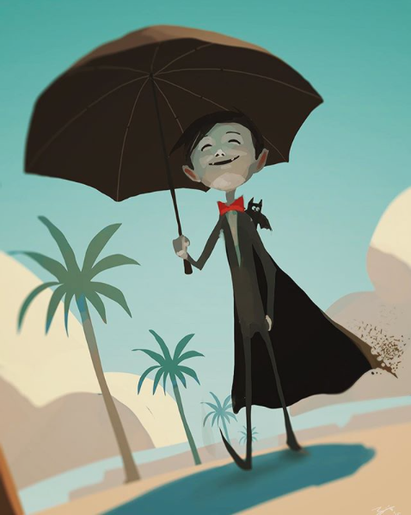
Before sharing the picture or the title:
- What do you imagine a vampire to look like? Draw it.
- What do you imagine a friendly vampire to look like? Draw it.
- Compare the two drawings. Can a vampire be friendly?
Share the image and title.
- How do you know that this vampire is friendly?
- Would you be his friend?
- Where is he? Where is he going?
- Why is he holding an umbrella?
- What is happening to his cloak?
- What do you think the bat is thinking/saying?
- What's going to happen next (in 5 minutes, in an hour, later that day, tomorrow...)?
Credit: Goro Fujita
http://chapter-56.blogspot.co.uk

© Once Upon A Picture

