BEAR AND CUB

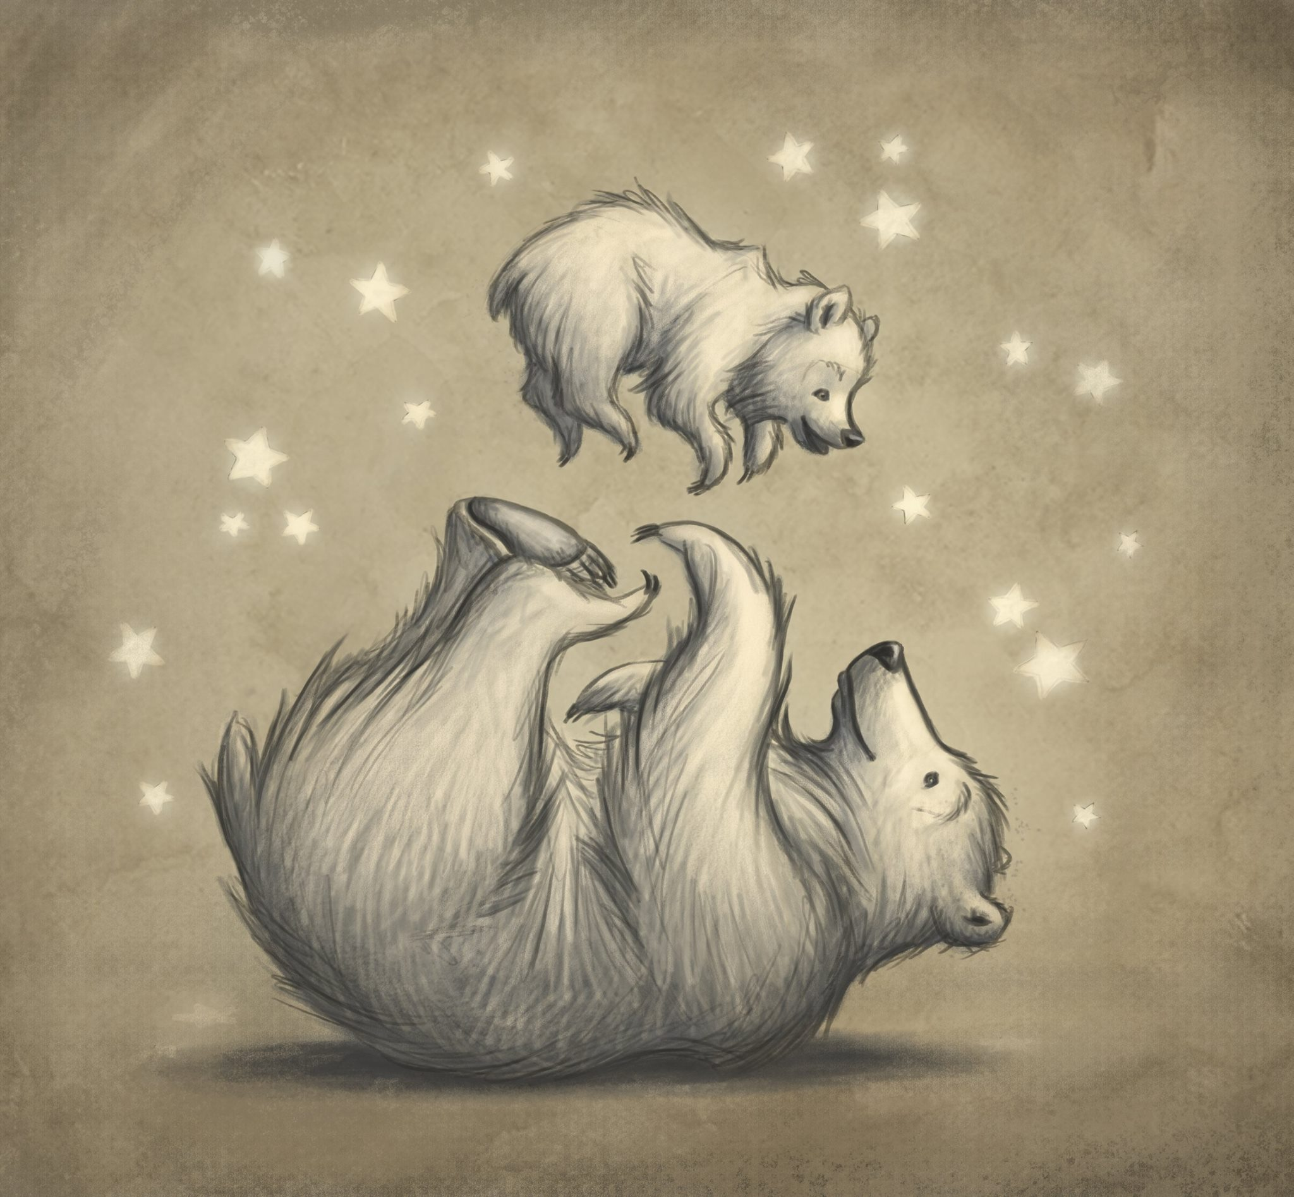

- How are the bears related? How old are they?
- What are they doing?
- How are they feeling?
- Is this a special moment?
- Why are there stars around them?
- Share a special memory between you and a parent/carer. Why do you think that time was special?

Credit: Ramona Kaulitzki
www.ramonakaulitzkiart.com

© Once Upon A Picture

