DRIFTING

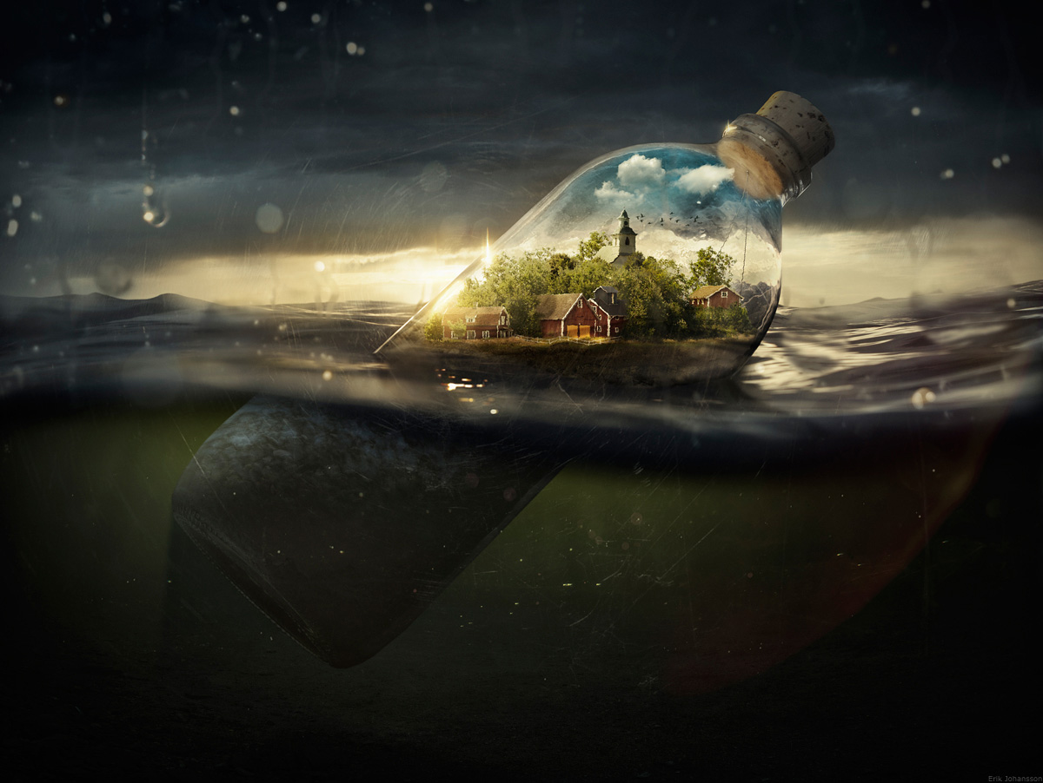

- What can you see inside the bottle?
- What is that place?
- Is it a miniature village inside an ordinary-sized bottle, or an ordinary-sized village inside a giant bottle?
- Has it always been inside the bottle?
- Does anyone live there? Can they feel the waves of the water outside the bottle?
- How did the bottle get here?
- Where is it drifting away from/to?

Credit: Erik Johansson
www.erikjohanssonphoto.com

© Once Upon A Picture

