BY THE LIGHT OF THE LANTERNS
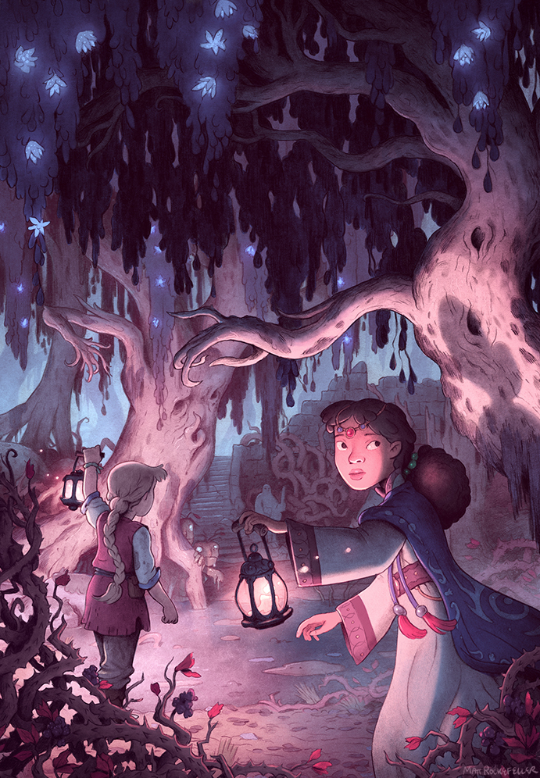
- What can you see in this setting? How would you describe it? Challenge: Use personification when describing the tree(s).
- What is this place?
- Why are some leaves glowing?
- What are the creatures hiding behind the tree?
- Do you think the trees are alive? Why/why not?
- Who are the characters? How old are they? What are they doing here? Why are they dressed in this way?
- Why are they both holding lanterns? Why are they looking in different directions?
- How are they feeling? How do you know?
- What might happen next? Write the story from this point.
Credit: Matt Rockefeller
www.mattrockefeller.com
Matt Rockefeller cover for The Secret of Dreawillow Carse by Brian Farrey
Algonquin Books 2015
© Once Upon A Picture

