LET’S FLY A KITE

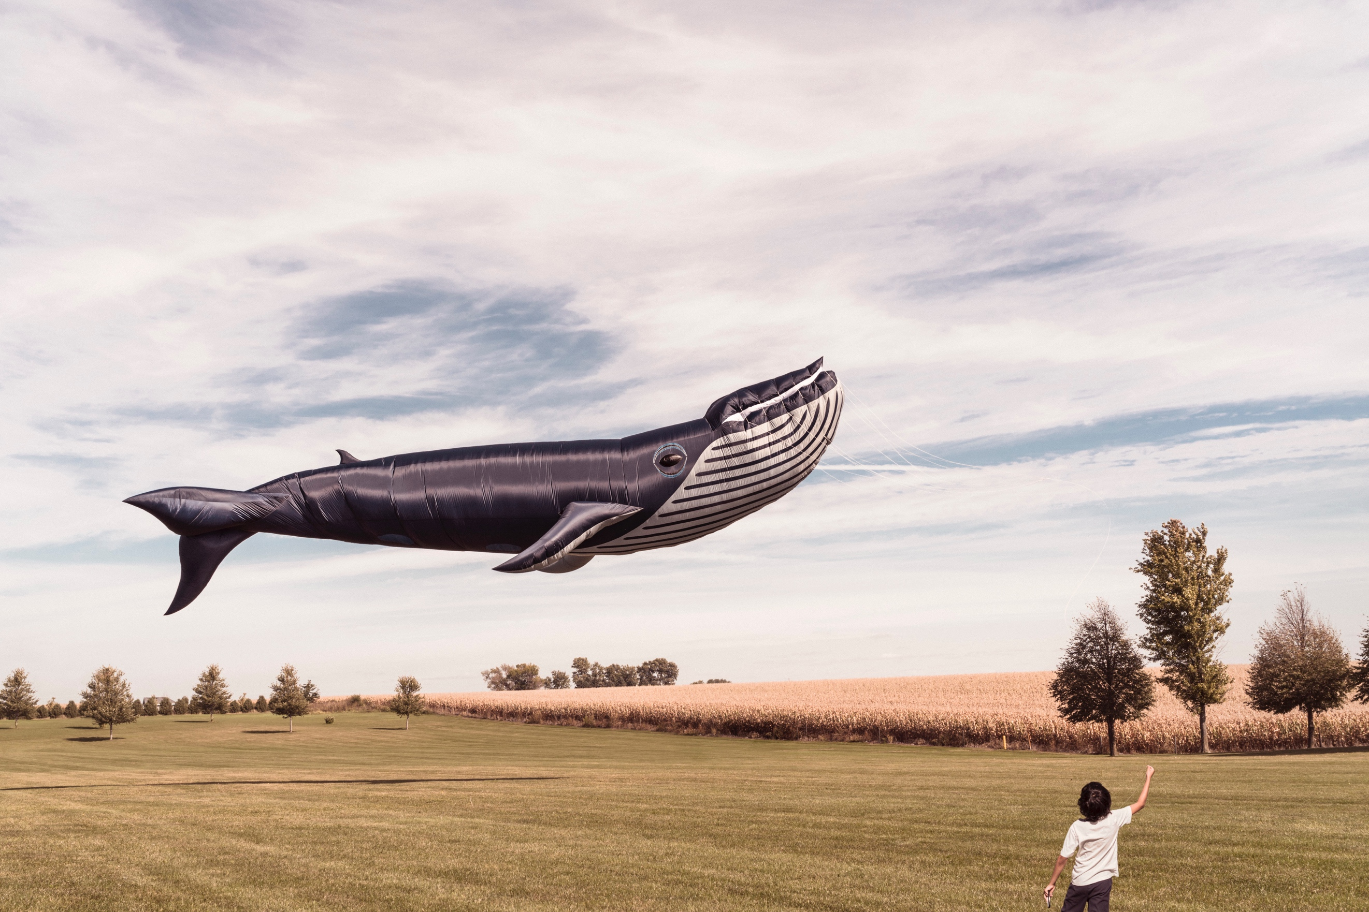

First, show the image without showing the title. Share first impressions/ideas:
- What can you see?
- What is happening here?
- Where did the whale come from?
- What is the boy doing?
- Tell a short story about a flying whale and a boy.
Share the title and zoom into the picture.
- Have you ever seen a kite like this one?
- Where did the boy get it from?
- Do you think it would be easy to fly?
- Did anyone show the boy how to fly this kite?
- Is this a suitable setting for flying a kite?
- Science link: How do kites work? How do you think this kite works?

Credit: Ryan McGuire
https://gratisography.com/

© Once Upon A Picture

