SHERLOCK

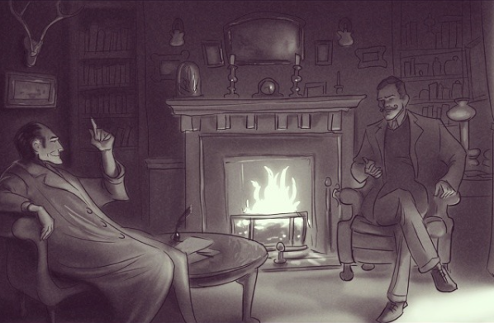

- What can you see in the picture? Make a list.
- What can you infer about the setting and the characters?
- Are these men friends/family/colleagues/enemies?
- Are they good or bad?
- Are they rich/poor? Powerful? Important? Intelligent?
- Where are they?
- What is written on the paper on the table?
- What time of day is it?
- What might they be saying to each other?
- If these men are detectives, what might they be discussing? Is this different to what you initially thought?

Credit: Tyler Carter
www.tycarter.com

© Once Upon A Picture

