KEEP OUT

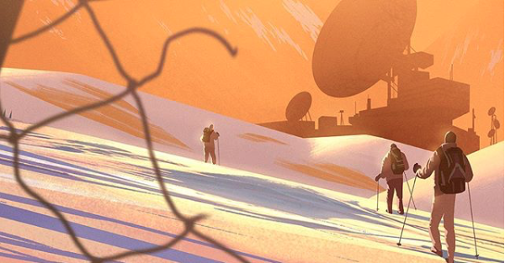

- What is this place? Where is it?
- Why is the picture called 'Keep Out'? What is the building for?
- Who broke the fence?
- Who do you think the people are?
- Where have they come from?

Credit: Tyler Carter
www.tycarter.com

© Once Upon A Picture

