MOST FIRES ARE STARTED BY FROGS
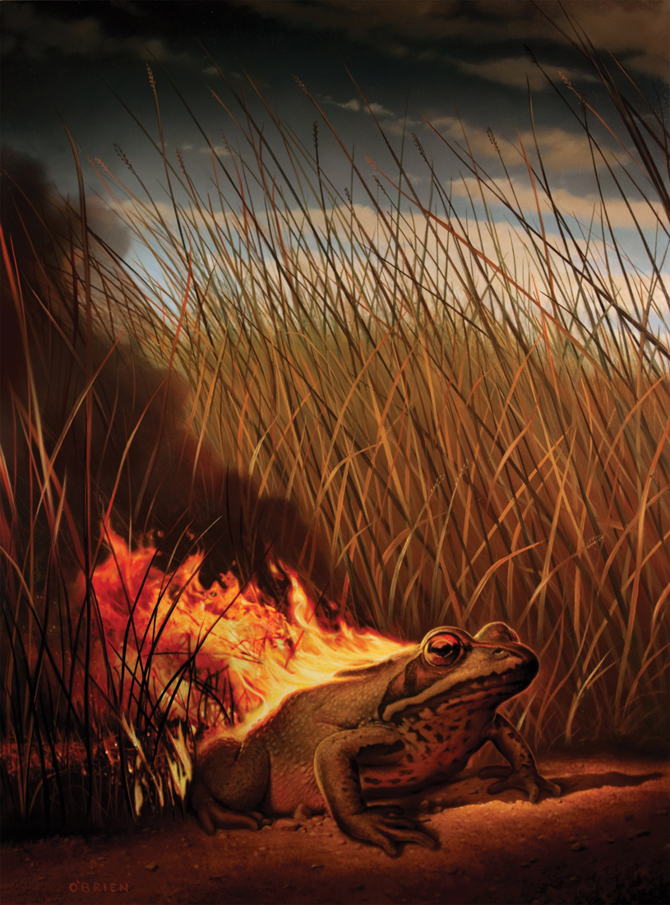
- What is happening here?
- Why is the frog on fire?
- Can it control the fire?
- How is the frog feeling?
- The title is 'Most fires are started by frogs'. Why do frogs start fires? How do they start fires? Write an explanation of this phenomenon.
- Who puts the fires out?
- Is there anything that humans can do to prevent these fires?
- Write instructions for preventing and/or extinguishing frog fires.
- In real life, what are the common causes of forest fires?
- What can be done to prevent them?
Credit: Tim O'Brien
www.obrienillustration.com

© Once Upon A Picture

