THE CLOCK TOWER
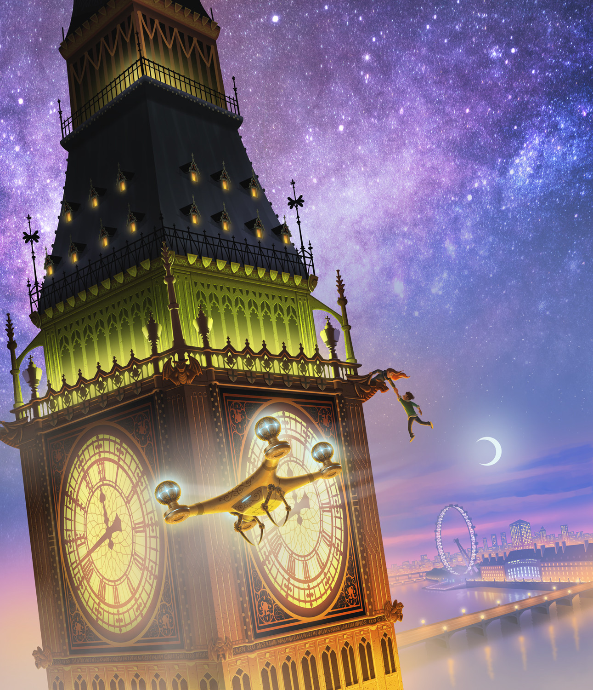
- What can you see in this setting? Where do you think this is? How has Petur chosen and used colours to create a mood?
- Who is the person hanging from the clock tower? How did he get there? Who is the person holding him? Are they allies or enemies? How do you know?
- What are they doing here? Does anyone know that they're there?
- Why is there a drone in the foreground? Does it belong to those characters or someone else?
- Is the time important?
- What will happen next?
- Write an adventure story using this image as inspiration. Will you use this event at the beginning, in the middle or at the end of your story? Challenge: How could you effectively use it as an opening to a story? What about the end of a story? Can you end a story on a cliffhanger?

Credit: Petur Antonsson
This is my cover for the Section 13 series by James R. Hannibal, book one, The Lost Property Office. Published by Simon & Schuster.
https://www.artstation.com/artist/paacart

© Once Upon A Picture

