A HUT ON CHICKEN LEGS
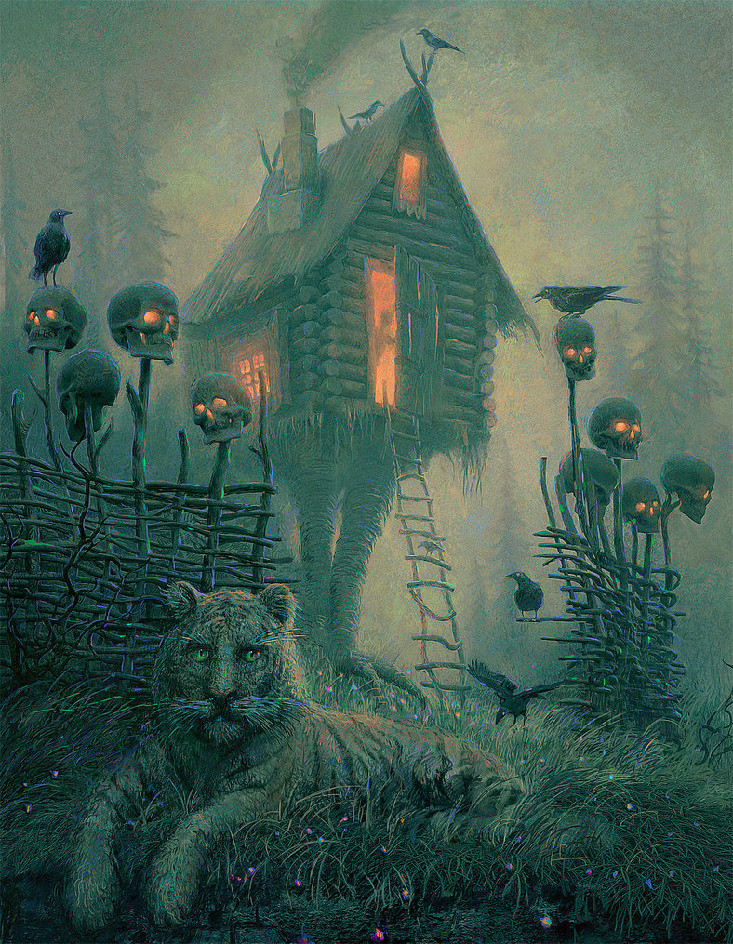
- What can you see in this picture? Look for the details you think others may miss.
- Why is the hut on chicken legs? Does it move? Who controls it?
- Who is the person in the doorway? What are they doing? Do they want to be inside this hut?
- Why is there a tiger in the foreground? Does it live here? Is it owned by someone or is it wild?
- Imagine you discover this place on a walk in the woods. How would you feel? What would you do?
- What kind of story would this setting best fit into?
- Write a short story based on this picture. Consider the atmosphere you want to create and choose your language and structure carefully.
Credit: Andrew Ferez
© Once Upon A Picture

