CAT SCHOOL
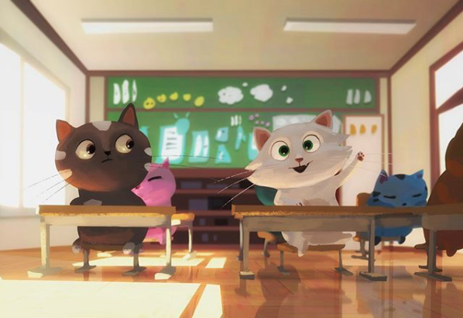

- Where do you think this is? How do you know?
- How many cats are in this class?
- What time of day is it? Why do you think that?
- Why is the white cat putting its paw up?
- What are the other cats doing/thinking?
- How is the black cat feeling? Why?
- Which cat is the cleverest? Which cat is the best behaved?
- Draw/describe what you think their teacher looks like.
- What do you think the other classes in the school are like?
- What lessons are taught in cat school?

Credit: Goro Fujita
http://chapter-56.blogspot.co.uk

© Once Upon A Picture

