DARK TOWER
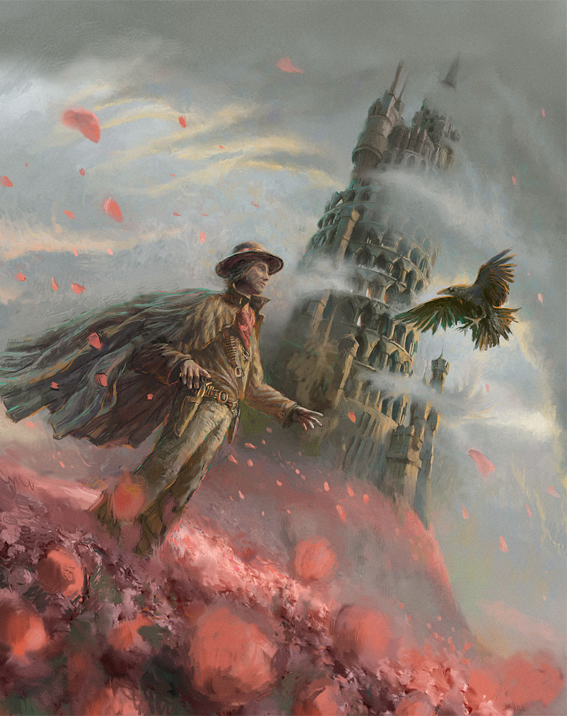

- Who is this man? Where has he come from? What does his clothing tell you about his character?
- Do you think he is a good or bad character? Why?
- What is he doing?
- Is the bird friendly or is it going to attack him?
- Describe the tower in as much detail as you can.
- Why is it called 'Dark Tower'?
- What do you think the tower is used for? Does anyone live there? Are there many visitors?
- What are the red things on the ground and in the air?
- What sounds could you hear if you were inside the picture?
- Use this picture as a story prompt. Include the dark tower as a setting, the man as a character and the bird as something else (a sidekick? A villain?).

Credit: Andrew Ferez

© Once Upon A Picture

