DREAM BIG
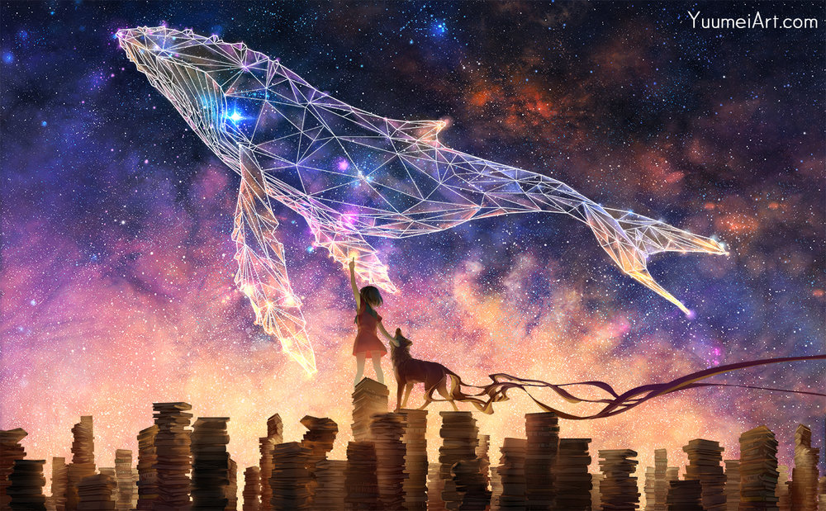

- What do you think is happening here?
- Why is the title 'Dream Big'?
- Is the girl touching the stars? Did she draw the constellation?
- Is the animal beside her a dog? A wolf? Something else?
- Why does it have trailing lines? Is it real? Is it her pet? Could it be a dæmon, like in Northern Lights?
- Why are they standing on piles of books?
- Does this picture have a message? What could it be?
- On Yuumei's website, this picture is accompanied by the caption, 'Let your imagination grow.' Why do you think this is?
Credit: Yuumei
www.yuumeiart.com – not all images are suitable for children

© Once Upon A Picture

