GLOW
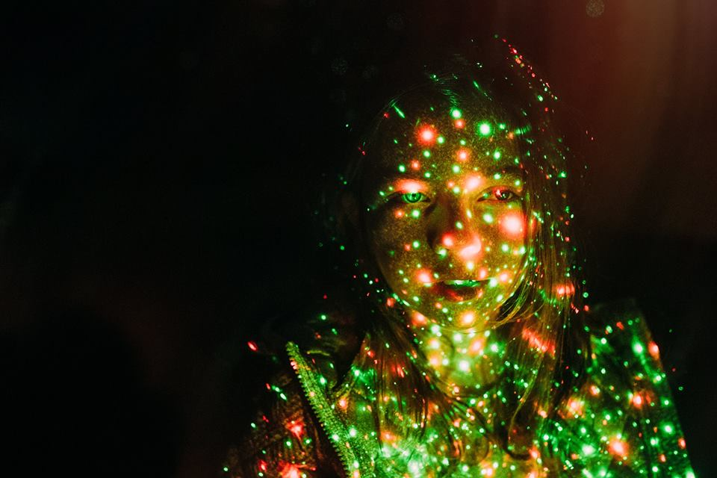

- Where is the light coming from? Is the girl the source of the lights?
- Why might she be glowing?
- Does she have any special abilities?
- Can she control them?
- Does she use them for good or bad?
- Is she the only one?
- What are her thoughts at this moment?

Credit: Kate Parker
www.kateparkerphotography.com

© Once Upon A Picture

