LET’S PLAY FOOTBALL
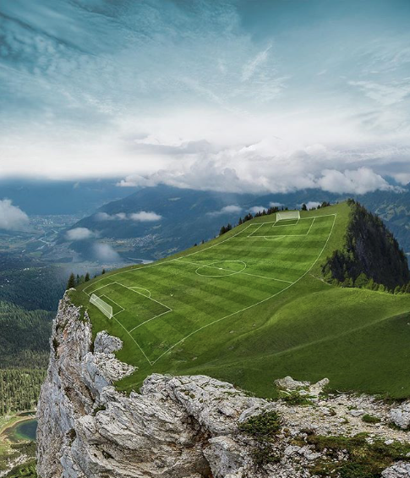
- What do you think of this setting?
- Is this a good place to play football? Why/why not?
- What are the pros? Cons?
- Which half/side do you think has the advantage?
- If you were playing here, how would you adapt to this pitch?
- Why do you think this pitch was built here?
Credit: Hüseyin Şahin
https://huseyinsahinart.com

© Once Upon A Picture

