NEMESIS
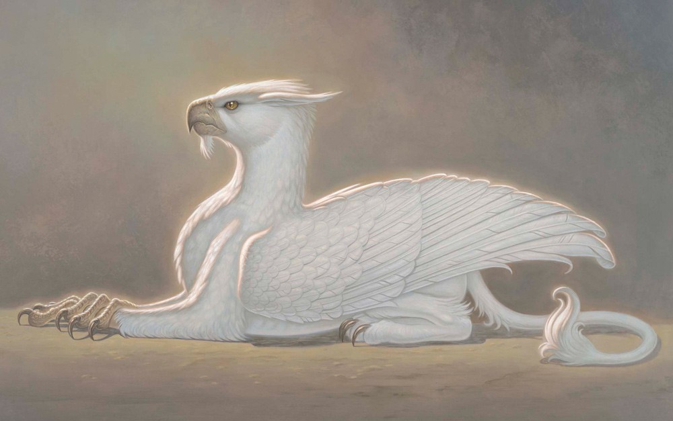

- What kind of creature is this? What is its species?
- Research griffins and hippogriffs. Could it be either of these?
- What do you think this creature eats? Where does it live? What is its personality/ temperament like? Do they live alone or in groups?
- Write an entry for 'Fantastic Beasts and Where To Find Them' about this creature.
- Explore the world of Fantastic Beasts here - you can visit locations from the film - perfect for setting descriptions and bringing your story to life.
- What does 'nemesis' mean? Have you heard that word before? What does it make you think of?
- Is this creature someone's nemesis? Whose?

Credit: Illustration © Paul Kidby, www.paulkidby.com

© Once Upon A Picture

