NO WORDS, JUST NOTES
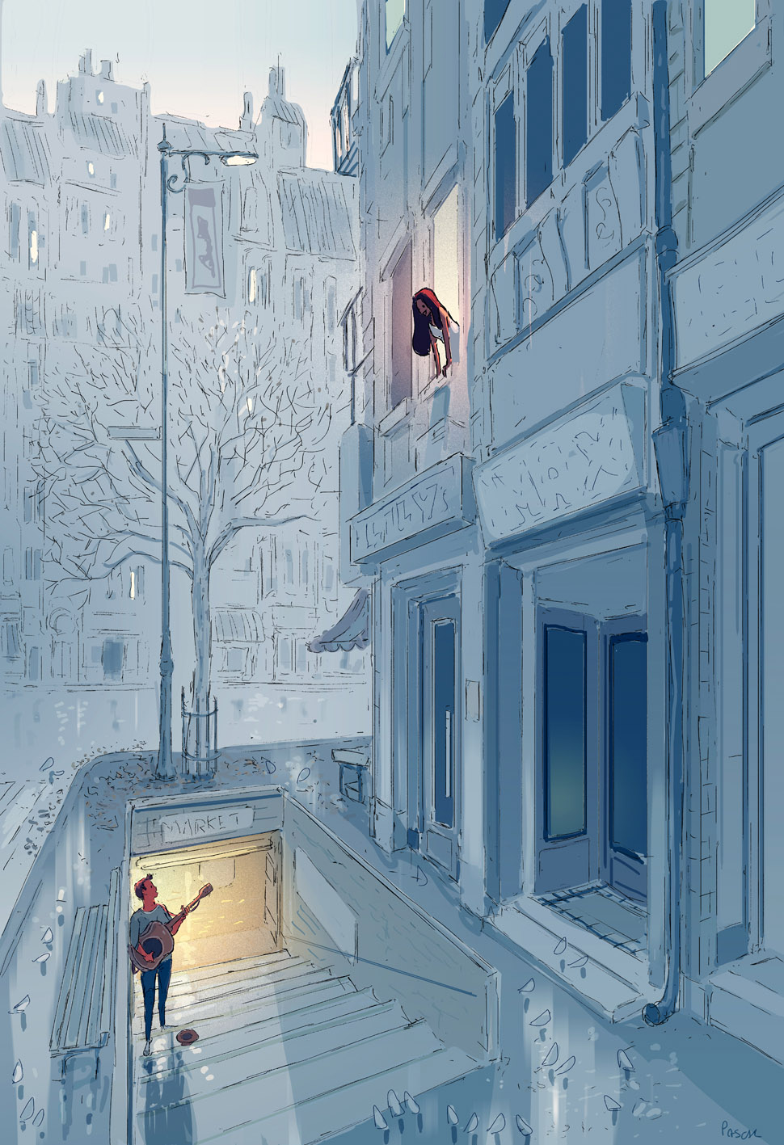
- What can you see? What do you think? What do you wonder?
- Where is the man coming from?
- What is he doing? Why?
- Why is he looking up at the woman? Why is she looking down at him? Do they know each other?
- Why is the shop called 'Lily's'?
- What do you notice about the use of colour and light in this image? Why do you think Pascal Campion made these choices?
- What are your thoughts on the title?
Credit: Pascal Campion
http://pascalcampion.blogspot.co.uk

© Once Upon A Picture

