SAID THE STARS
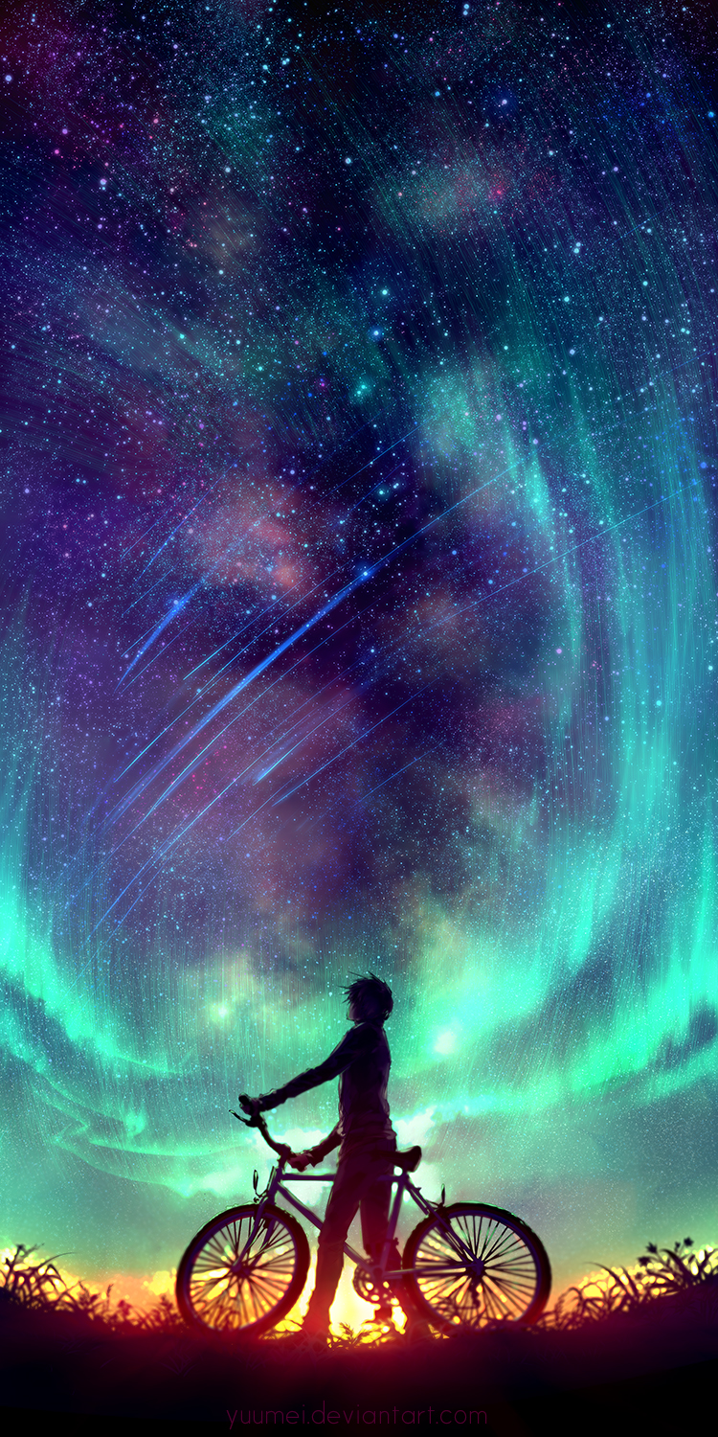
“Look up,” said the stars, “and all your dreams will reveal themselves.”
- This image and sentence could be used as a standalone prompt - let children lead a discussion, generate their own questions, or write freely and creatively.

- What can you see?
- What makes this image so beautiful?
- Who is the person?
- Why are they holding a bike? Where have they come from? Where are they going? Why aren't they riding the bike? Why have they stopped?
- Why is the person looking up?
- Are the stars speaking?
- What are the person's dreams? How will they reveal themselves?

Broader questions:
- If the stars could speak, what sort of things do you think they might say? Would they tell stories, give advice/warnings, ask questions?
- What are dreams?
- Do you have any dreams?
- How is a dream similar/different to a goal or a wish?
- Can you do anything to help yourself to achieve your dreams?

- Science link: stars, space, earth & rotation, night & day, aurora borealis

Credit: Yuumei
www.yuumeiart.com - not all images are suitable for children

© Once Upon A Picture

