SUMMER GETAWAY
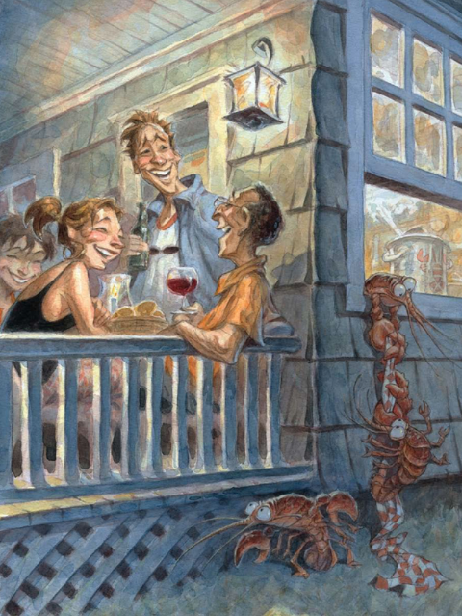
- What do you think is happening here?
- Why are the lobsters escaping?
- Do the people know?
- What do you think will happen next? Will they be caught or will they go free?
- What will the lobsters do when they get away? Write about the adventures of the escaped lobsters.
- Should people eat lobster? Why/why not?
Credit: Peter de Sève
www.peterdeseve.blogspot.co.uk

© Once Upon A Picture

