THE THING IN THE SEWER
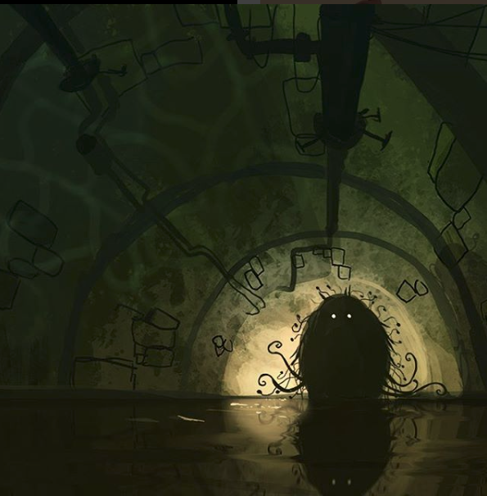

- What is the thing in the sewer?
- Does it have arms and legs? How does it move? Why does it have tentacles?
- Does it live alone?
- Why do its eyes glow?
- Why does it live in the sewer? Can it venture above ground? Can it survive above ground?
- What does it eat?
- Write an information page about 'the thing in the sewer'. Give the creature a name, and choose your sections - e.g. diet, appearance, behaviour.
- How was the species discovered? Who by?
- Write an explorer's journal entry detailing the discovery.
- What should you do if you meet 'the thing'?
- Write some instructions for people who may need it e.g. sewer workers, construction workers, criminals...
Credit: Goro Fujita
http://chapter-56.blogspot.co.uk

© Once Upon A Picture

