GIRL AND DRAGON
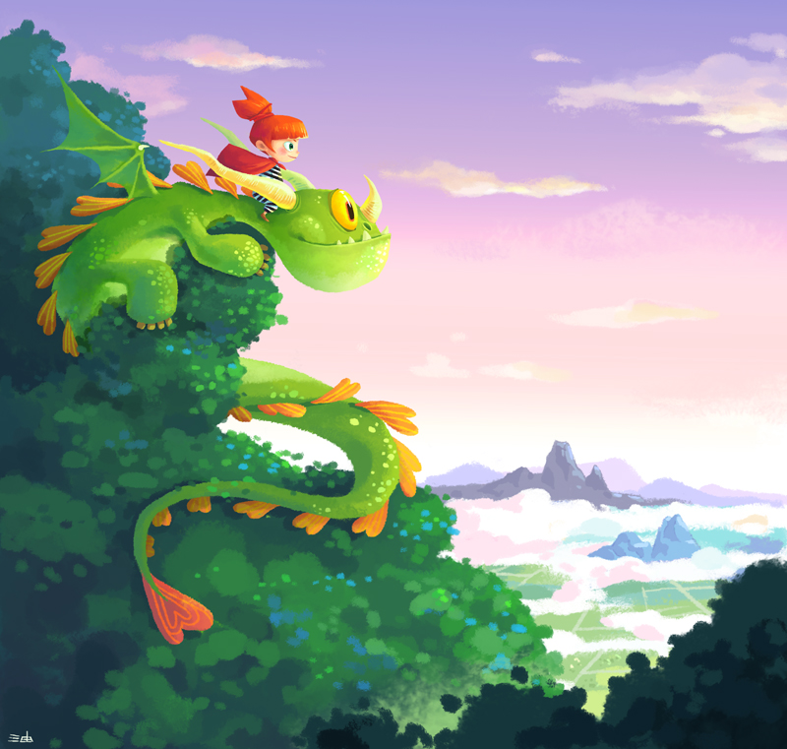

- Where are the girl and the dragon? What can they see from this place? What are they looking at?
- Why are they here?
- Are they friends? Does the girl own the dragon as a pet? Or does the dragon own the girl as its pet?
- What species of dragon do you think it is? Is it friendly?
- Does anyone else know that they're up here? What might other people say about their friendship?
- Give this picture a new title. Explain your choices and persuade others that yours is the best title.
- Write about the adventures of the girl and the dragon.
Credit: Little Oil/ Jhao-Yu Shih
http://littleoil.tumblr.com
© Once Upon A Picture

