MAGIC RABBIT
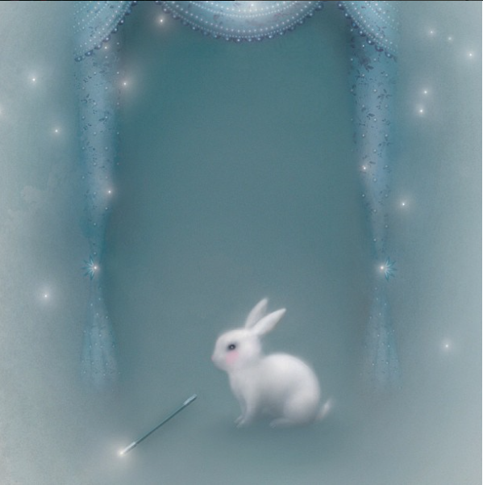
- How does this picture make you feel? Why?
- Why are white rabbits associated with magic?
- Can this rabbit perform magic tricks?
- Is it a magician?
- Write a story from the rabbit's perspective. You could use this as your starting point:
Ladies, gentlemen, boys and girls,
Welcome to the show,
Where you will see such sights that you'll be certain your eyes deceive you.
But first, if you'll allow me, I shall tell you my tale.
It is a tale of surprise, of daring, of wonder,
And - most of all - of finding magic where you least expect it.
For I am not the assistant.
I am not the trick.
I am the magician.
Credit: Lisa Evans
www.firefluff.com

© Once Upon A Picture

