WHO’S THERE?
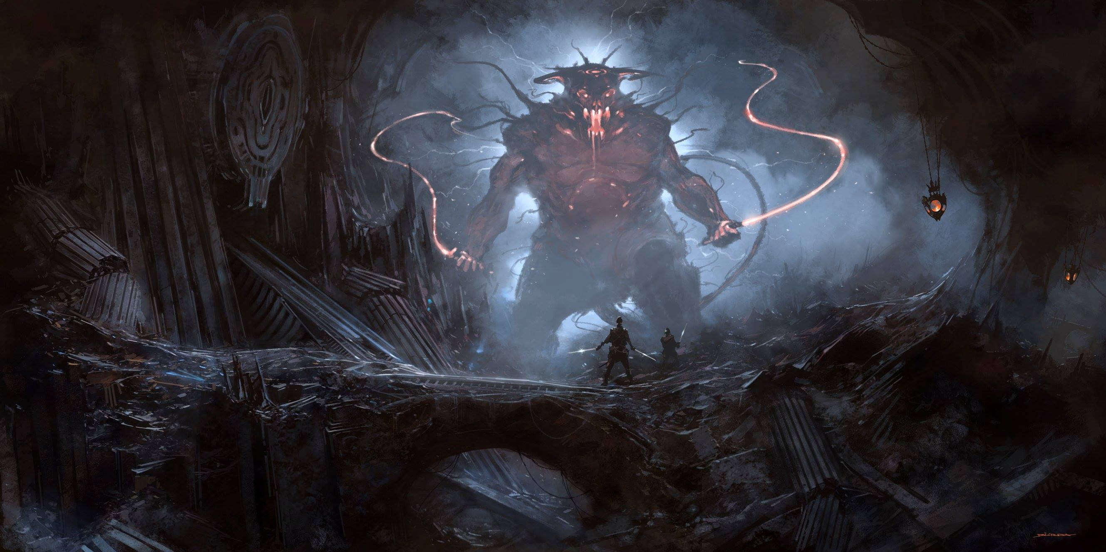
- Where is this? Is it underground or above ground? Has it always been this way?
- Describe the monster. Consider its size, shape, the light in its face and how it moves. How does it communicate? What is it holding?
- Where did the monster come from? Does it live here?
- Did the people in front of the monster come here looking for it?
- Why do they have swords? Are they ordinary swords?
- What do you think could happen next? What is the most likely choice?
- Use this picture as a stimulus for a short story (under 200 words).
Credit: Alejandro Burdisio/Burda
Facebook page

© Once Upon A Picture

