DRAGON
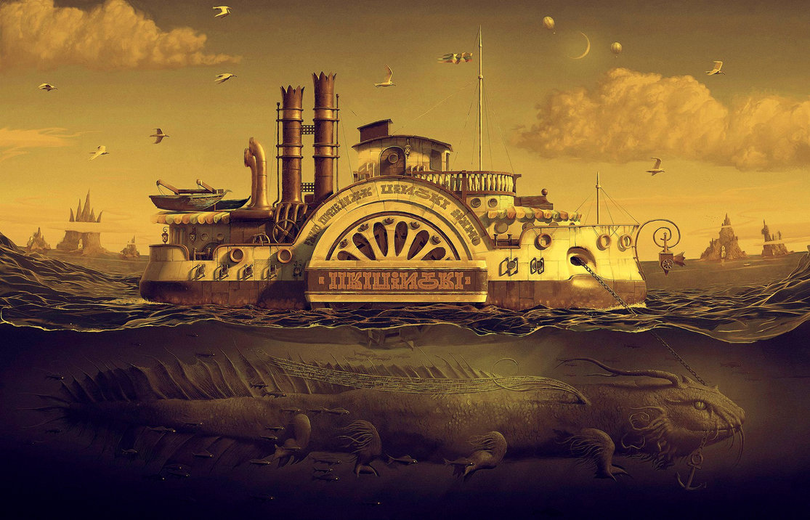

- What can you see? What do you think is happening/has happened/will happen? What do you wonder? See think wonder
- Who owns this boat? Where is it from? Where is it going? Who travels on this boat?
- What can you see beneath the surface of the water?
- What is the creature called? Describe the creature. Consider its eyes, mouth, legs, tail and other details.
- What is the creature doing?
- Why does it have the anchor chain in its mouth?
- Has the creature been asked to pull the boat in this way? Is it under control or out of control?
- Where is it taking the boat?
- Why is it acting in this way?
- Why are the fish swimming alongside the creature?
- Who is in the hot air balloons?
- Write a 100 word story about this picture. Try to include some of the words on this page: Dragon vocabulary
Credit: Andrew Ferez

© Once Upon A Picture

