GEOMANCER

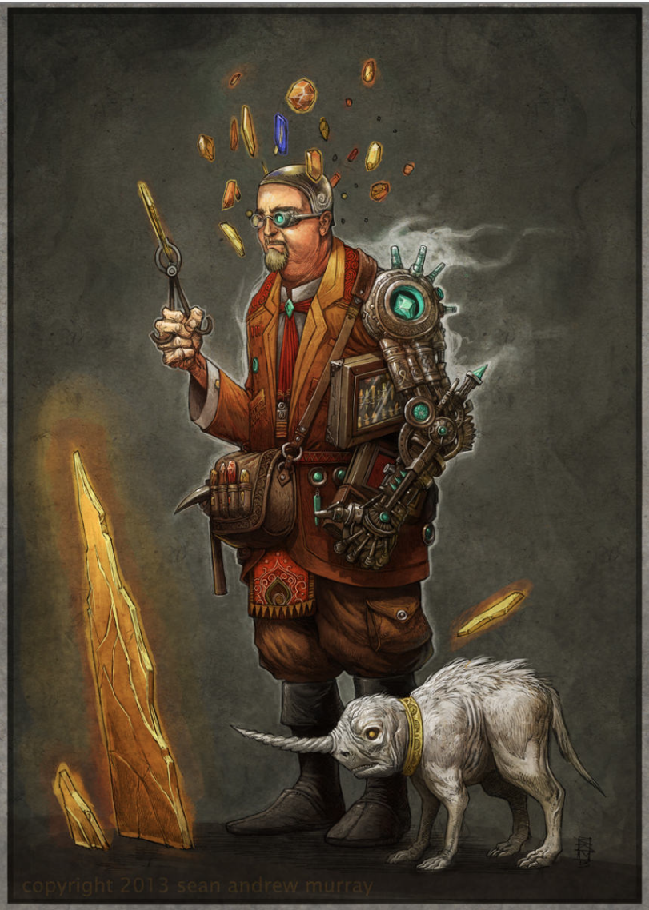
First, show without sharing the title.
- Who is this man?
- Why does he have so many unusual objects on his person?
- Does he have a job? What does he do? Does he have any hobbies?
- What is he looking for?
- Why are there crystals floating around his head?
- What happened to his arm?
- What is the creature next to him? Does it belong to him? How do you know?
Share the title.
- What do you think 'geomancer' means? What does 'geo-' mean? Is it in any words you know?
- Share a definition of geomancy (divination by geographic features or by figures or lines). What does this mean?
- What can he tell by looking at these rocks/crystals?
- Who would listen to him?
- Zoom in on the case under his arm, or his satchel. What's inside it? Write short descriptions of the things you might find inside.
- Does this man work with other people?
- Write a short story about this man.
- Compare the geomancer with the Jar Wizard. What's similar? What's different? Would these men get along?
Credit: © Sean Andrew Murray
seanandrewmurray.com
© Once Upon A Picture

