LIGHTS
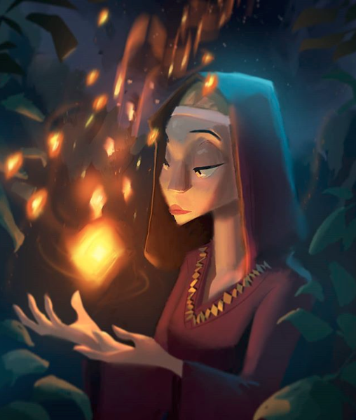
- Who is this woman?
- What do her clothes tell you about her?
- What is she doing?
- What are the lights?
- Have you ever seen anything like this? Is this real or fantasy?
- Why is she doing this? Why at night time?
- Is anyone else with her?
"At the close of each day she spun the night sky."
- Now what do you know about her?
- What is her job?
- Does she have to spin the night sky? Who told her to do it? How long has she been doing it? What happens if she doesn't spin the night sky? What happens at sunrise?
- Write a short story about a time she doesn't spin the night sky. Will it have a positive resolution or not? Why?
Credit: Tyler Carter
www.tycarter.com
© Once Upon A Picture

