ENOKI TALES

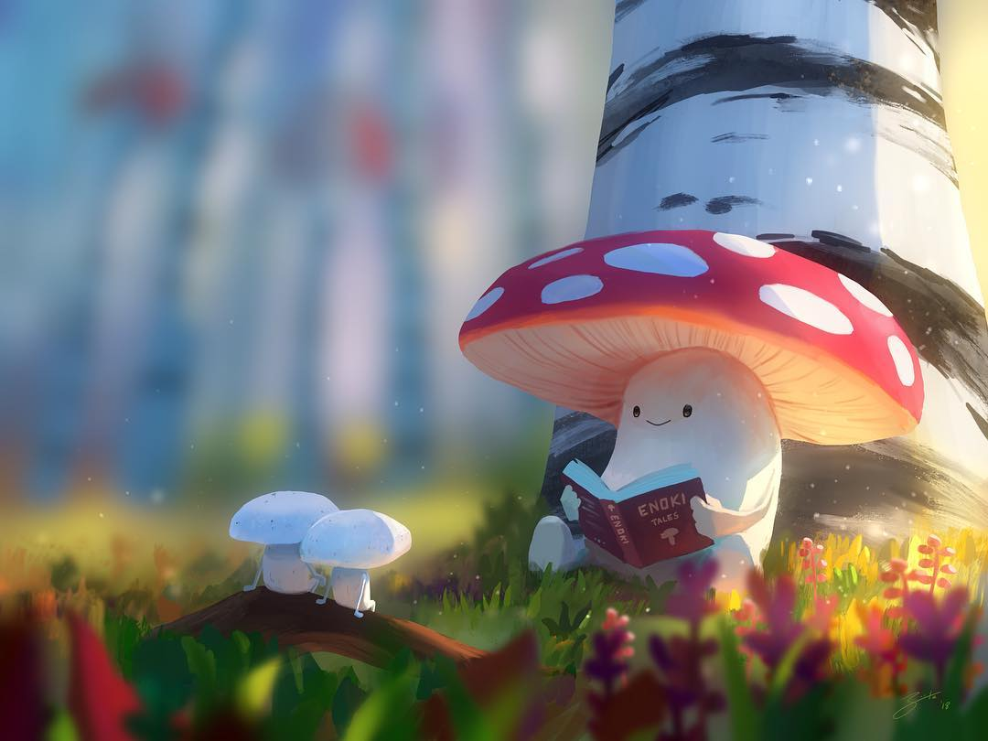

- What's happening here?
- Do the two smaller mushrooms know the larger one?
- Have they done this before? How do you know?
- What is the larger mushroom reading? What kind of thing might you expect to find inside this book?
- 'Enoki' is the type of mushroom (it is the Japanese name for it, as it's highly popular in Japan). Are the smaller mushrooms of the same species?
- What do you think might be in the background?
- Write a story that might belong in the book, 'Enoki Tales'.
- Research the enoki mushroom. Find recipes including this food. Find out how not to confuse it with the Galerina marginata mushroom, and why this is important.

Credit: Goro Fujita
http://chapter-56.blogspot.co.uk

© Once Upon A Picture

