FISHING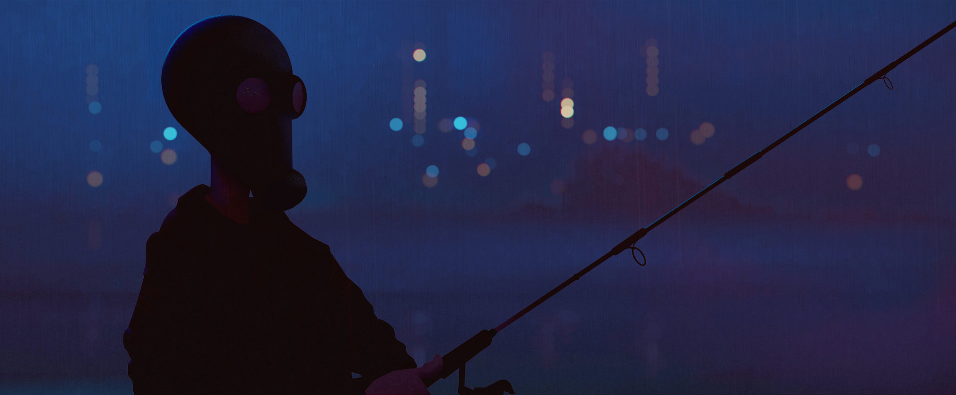
- What can you see?
- What do you think is happening here?
- Why is the person wearing a mask?
- What are the dangers in this scene?
- Who is this person?
- What else is in the background? Are there any other people around?
- Write a first person narrative set in this world.
Credit: Henrik Evensen
https://www.artstation.com/artist/selvestehe
© Once Upon A Picture

