TRAIN
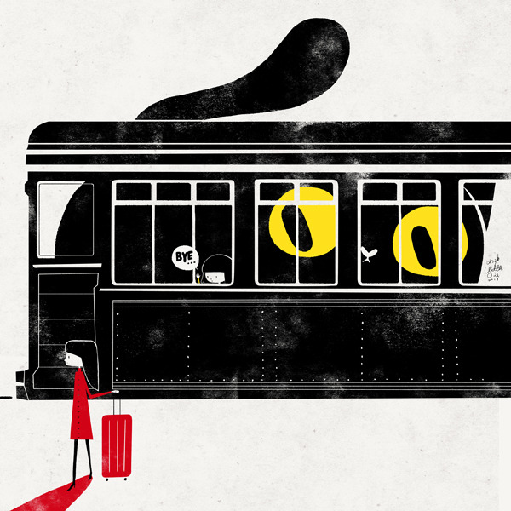
- What's happening here?
- Who are the two characters?
- Why aren't they on the train together?
- Is the train arriving or departing? How do you know?
- Why is the cat on the train?
- How do you feel when you look at this picture? Why do you think that is?
- What do you think about the use of colour in this image?
- Tell the 'before' of this story. How did it get to this point?
Credit: Little Oil/ Jhao-Yu Shih
http://littleoil.tumblr.com

© Once Upon A Picture

